
Université d’Ottawa University of Ottawa
Faculté de Génie Faculty of Engineering

École d’Ingénierie et de School of Information
Technologies de l’Information Technology and Engineering

ITI11001X-Digital Systems I (Summer 2008)

Student Name (Please print)______________________________________________

Student Number____________________________________

Examiner: Abdul Al-Dhaher Date: July 18, 2008

Time: 3 hours

Instructions:
- Answer ALL questions.
- This is a close-book examination, no lecture notes or book is allowed. Calculator is allowed
- Use the provided space to answer the following questions. If more space is needed, use the back of the page.
- Show all your calculations to obtain full marks.
- Calculators are allowed.
Question # | Mark
1
2
2
4
5
Total

Question 1 (15 marks)
Part A (5 marks)
Given on the following unsigned numbers:

A = 125
B = 1800

- Use 9’s complement to perform:

A - B

B – A

- Use 10’s complement to perform

A - B
B – A

Question 1 Part B (10 marks)

Given A = (12.5)₈ and B = (2.5)₁₆. Convert these numbers into Binary use necessary number of bits and perform the following operations:

- Use 1’s complement to perform the following operation
A – B
B – A

- Use 2’s complement to perform the following operation
A – B
B – A

Question 2: (20 marks)
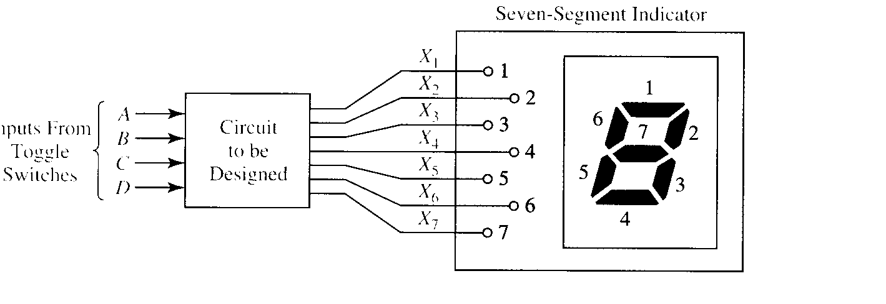
The seven-segment indicator (shown in the figure) can be used to display any of the decimal digits 0 through 9. For example “1” is displayed by lighting segment 2 and 3 and “8” by lighting all seven segments. A segment is lighted when logic 1 is applied to the corresponding input on the display module.

Design an excess-3 code convertor to derive a seven segment indicator. The four inputs to the converter circuit (A, B, C, D in the figure) represent an execess-3 coded decimal digit. Assume that only input combination representing the digit 0 through 9 can occur as inputs, so the six unused combinations are don’t cares. Design your circuit using only 2-, 3- and 4-input NAND gates and inverter. Try to minimize the number of gates and inverter required. The variables A, B, C and D are available from toggle switches.


Question 3 (15 marks)

Question 3 part A (8 marks):
Realize (develop) the circuit for full adder using 3-to-8 line decoder with:

- Two OR gates
- Two NOR gates

- Write the truth table
- Write the simplified (using K-map) expression for the outputs
- Draw the circuits

Question 3 part B (7 marks):
Derive the logic equations for a 4-to-2 priority encoder. Write the truth table first and show the highest and lowest priority inputs. Use K-map to simplify the expressions.

Question 4 (15 marks)
Design a sequential circuit with two JK flip-flops A and B and two inputs E and x. If E = 0, the circuit remains in the same state regardless of the value of x. When E = 1 and x = 1, the circuit goes through the state transitions from 00 to 01 to 10 to 11 back to 00, and repeats. When E = 1 and x = 0, the circuit goes through the state transitions from 00 to 11 to 10 to 01 back to 00, and repeats.

(i) Give a table that shows:
a. the input values
b. the states (present and next) for the JK flip-flops
c. the JK flip-flop inputs
(ii) Using Karnaugh maps, find the minimal sum-of-products form of the equations for the inputs to the JK flip-flops.
(iii) Draw the circuit

Question 5 (35 marks)

Question 5 Part A (15 marks):

Design asynchronous (ripple) counter, up count counter, with a modulo-13 using D flip-flop:
- Build the state diagram
- Draw the logic circuit

Question 5 Part B (20 marks):
Design synchronize downward decade counter which counts in the sequence:

0000, 1001, 1000, 0111, 0110, 0101, 0100, 0011, 0010, 0001, 0000, 1001 and repeat.

Use J-K flip-flops

- Show the state table together with the inputs to the JK flip-flops
- Write the simplified logic expression for the inputs to the flip-flops
- Draw the state diagram
- Draw the circuit
- Draw complete state diagram for the counter showing what happen when the counter is started in each of the unused states.

